Linda Oliver
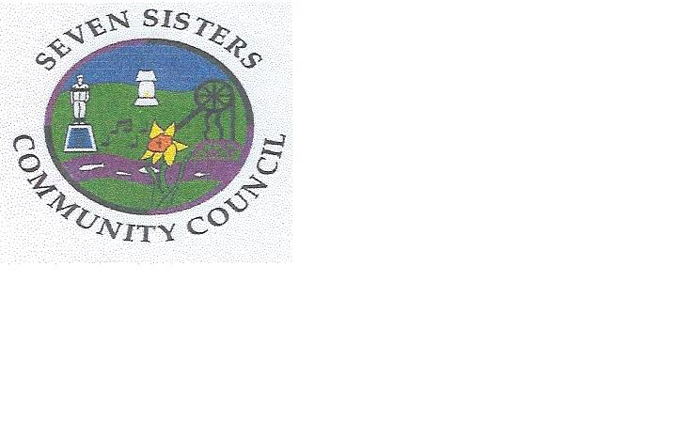
Clerk to the Council
Brodawel
Onllwyn Road
Coelbren, Neath
SA10 9NS Tel:01639 700525/07774 718663
linoliver@btinternet.com

WOULD YOU LIKE TO BE INVOLVED IN WHAT HAPPENS IN YOUR VILLAGE

SEVEN SISTERS COMMUNITY COUNCIL IS LOOKING FOR YOUR HELP!

WE WANT TO START AN EVENT’S COMMITTEE TO DECIDE HOW WE CAN MAKE LIFE IN THE VILLAGE MORE ENTERTAINING AND INTERESTING FOR EVERYONE

IF YOU HAVE SOME TIME TO SPARE AND WOULD LIKE TO CONTRIBUTE YOUR IDEAS AND HELP TO THE PROJECT, WE WOULD LOVE TO SEE YOU AT THE FOLLOWING MEETING:

Monday 25th March 2019 at the Community Hall at 6p.m.

