Linda Oliver
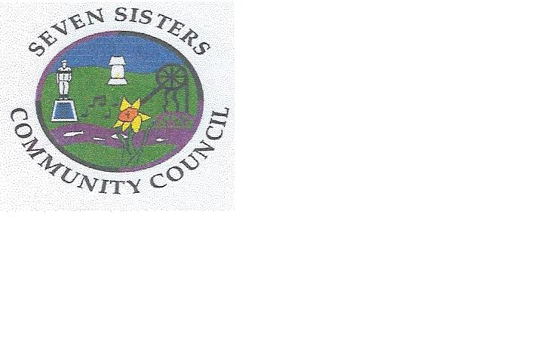
Clerk to the Council
Brodawel
Onllwyn Road
Coelbren, Neath
SA10 9NS Tel:01639 700525/07774 718663
linoliver@btinternet.com

The Soar Congregational Church at Seven Sisters

Decision of the Seven Sisters Community Council on 3 February 2020

As of course is well known throughout the community of Seven Sisters, the Soar Congregational Church which was owned by Howard Rees Limited regrettably fell into a state of disrepair and neglect in or around April 2016 following works at the site. Despite the best endeavours of the Council and Neath Port Talbot County Borough Council as the local planning Authority (which required the condition of the land to be remedied) the company Howard Rees Limited became dissolved in May 2016, leading to the land passing effectively ownerless, to the Crown Estate.
In an attempt to scope the viability of acquiring the site, the Community Council made enquiries of the Crown Estate to ascertain the possible costs of purchasing the site on behalf of the community, as well as considering the costs of maintaining the site after acquisition.
At a meeting of the Council on 3 February the Council received a report dealing with the possible purchase costs; the costs of remedying the poor condition of the site and the projected costs of maintain the land thereafter. These costs amounted to a minimum of £9000 broken down as follows Purchase of site £5000, Legal costs and survey £4000 plus VAT, plus ongoing costs to reinstate the site and maintain it thereafter, to include insurance costs.
The Crown Estate is legally obliged to secure the best possible purchase price for land which has passed to it.
After careful consideration of the purchase costs, the costs to the Community Council of reinstating the site and the projected costs of maintaining the site thereafter, the Council resolved, with regret, that it was unable to purchase the land. Whilst the Council recognised and appreciated the importance of the Church and the cemetery to the residents of Seven Sisters it also acknowledged that the funds at its disposal were relatively small and were subject also to other competing demands within the community. It was also recognised that the purchase of the site would be an ongoing financial obligation, falling to the public purse. With heavy heart therefore the decision was made not to purchase the land. Balancing the interests of the community against the resources at its disposal is not an easy task, and the Council recognises the disappointment which will be felt in the community following its decision; on balance however, it considered this to be the right decision.

