Linda Oliver
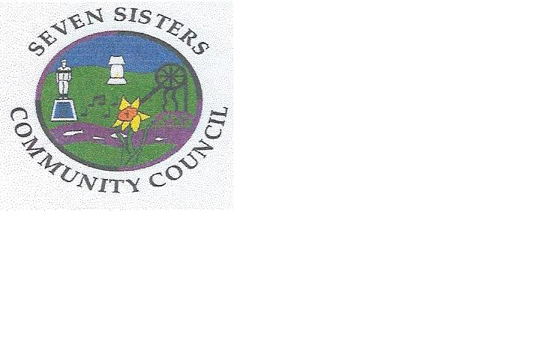
Clerk to the Council
Brodawel
Onllwyn Road
Coelbren, Neath
SA10 9NS Tel:01639 700525/07774 718663
linoliver@btinternet.com

Certification and approval of annual accounts for 2019-20

Regulation 15(1) of the Accounts and Audit (Wales) Regulations 2014 (as amended) requires that Responsible Financial Officer of Seven Sisters Community Council sign and date the statement of accounts, and certify that it properly presents Seven Sisters Community Council’s receipts and payments for the year The Regulations required that this be completed by 30 June 2020.

Due to the COVIC-19 outbreak, Seven Sisters Community Council has not met to approve the accounts.

Linda Oliver
Clerk and Responsible Financial Officer

