Linda Oliver
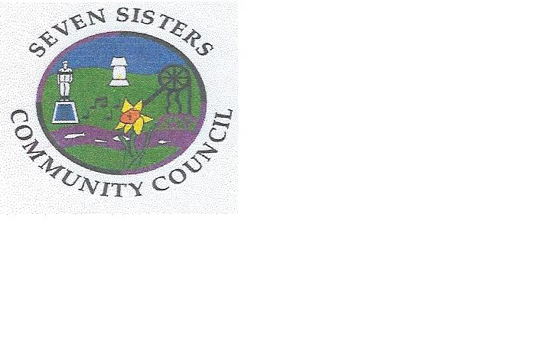
Clerk to the Council
Brodawel
Onllwyn Road
Coelbren, Neath
SA10 9NS Tel:01639 700525/07774 718663
linoliver@btinternet.com

COMMUNITY COUNCIL MONTHLY MEETING

MONDAY 12TH APRIL AT 6.30P.M.

The Community Council would like to invite residents of Seven Sisters to observe their virtual meeting on the above date.

Residents will be able to observe proceedings via Zoom but are not allowed to participate in the meeting in any way.

If anyone is interested would they please contact me at linoliver@btinternet.com by Tuesday 6th April at the latest, so that I can let them have a link to join the meeting.

Linda Oliver
Clerk

