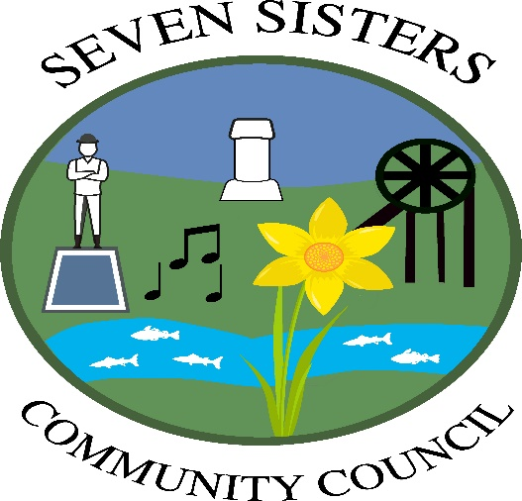

Cyngor Cymuned Blaendulais

ANNUAL REPORT 2025/6

Context

During 2025/6 the Council comprised of 12 Councillors who were fully committed to representing the residents of Seven Sisters and providing them with services and facilities designed to enhance the social and environmental well-being of the community. The Councillors who were in office that year were:

Mrs Emyr Wyn Francis – Chair
Mrs Hayley Jones – Vice Chair
Mrs Julia Adams
Mrs Andrea Bowen
Mr Christian Davies
Mr Carl Hamer
Cllr Stephen Hunt
Mr David John
Mr Marc Lewis
Mr Gareth Lias
Miss Allison Price
Miss K Wood

The Clerk was Mrs Linda Oliver

As at 31st March 2026 there were 12 Councillors, all of whom had signed a declaration of acceptance of office upon their appointment.

At the head of the Council is the Chair who was elected by members at the start of the year, as was the Vice Chair.

The Council met on the first Monday of each month, barring August, at the Seven Sisters community hall, commencing at 6.30p.m.

1
The public are welcome to attend the meetings and ask questions either at the start or end of the meeting. However, it should be noted that members of the public cannot partake during the meeting itself.

The Council had a number of sub-committees, with Councillors duly elected to these at the annual meeting held in May. The sub-committees during the year were:

ORGANISATION MEMBER

Brynbedd Cemetery Mrs J Adams
Mrs A Bowen
Mr C Hamer
Mr G Lias

Recreation Ground Mr C Davies
Mr C Hamer
Mr D John
Miss A Price

Hall Management Committee Mrs A Bowen
Miss A Price

Footpaths All Councillors

NPT Council/Community Council Liaison Mrs A Bowen
Committee

Planning Applications (where observations are Chair
required prior to the next council meeting) Vice Chair
Mr C Davies

Ysgol Gymraeg Blaendulais Mr E Francis
Mrs A Price

Blaendulais Primary School Mrs H Jones
Mr D John

Legal Liaison and Signing of Documents Chair
Vice Chair
Clerk

Cheque Signatories Mr D John
Mrs H Jones
Miss A Price
Miss K Wood

GCRE (Global Centre of Rail Excellence) Mr D John
2

Financial Information

£
Balance brought forward as at 1st April 2025 18,269
Income from local taxation 65,286
Total other receipts 41,599

Sub Total 125,154

Staff costs 31,301
Loan interest/capital repayments 2,711
Total other payments 74,681

Sub Total 108,693

Balance carried forward as at 31st March 2026 16,461

Total value of assets owned by the Council was £374,982

Total borrowing was £2,680

The accounts were approved at Council and submitted to the internal auditors, Ridgewood Associates, who stated there were no areas of concern.

They will be submitted to the external auditors, Audit Wales, by the due date.

Code of Conduct

All Councillors are aware of their responsibilities and obligations as set out in Seven Sisters Community Council Code of Conduct and the standards expected of them in public life.

Assets and Services Owned or Managed by the Council

Seven Sisters Community Hall and play area
Brynbedd Cemetery
Seven Sisters Recreation ground
School crossing patrol

The Community Council are a statutory consultee for the local authority and government issues including planning.

3

Council Activities during 2025/6

Community Hall

The community hall is used regularly by many residents of Seven Sisters and the Dulais Valley.
The day to day management of the hall is by CHAOSS (Community Hall Association of Seven Sisters) which comprises a voluntary group of residents

User groups that regularly meet at the hall:
Art
Bowls
OAP’s
Brownies
Needles and Natter
Lunch Club
Stroke Group
Yoga
TaGN Soo Do (martial arts group)
Baby Group
Bingo,
Stay and Play
Me, Myself and I
Youth Club
Burlesque
Playful Splatter (messy play sessions for the under 5’s)

Over the past year, the hall has hosted a wide range of events and activities, all of which have been well attended:

Every Thursday, the Warm Hub was held, welcoming up to 50 people, and funded by a grant received.
The Stay Safe Team visited for a dedicated day.
Sip and Paint event
Wreath-making session
Foot Clinic attends once a month
Free Kids’ Fun Day
Medium Evening
Animal Cwtch session
Craft Fair
Christmas Fair with Father Christmas
Free Easter event for children
and numerous party bookings throughout the year

4

The Council, via the work of Miss Allison Price, has applied for and received numerous grants from Neath Port Talbot council throughout the year for improvements to the hall, including:

Replacement of doors and windows
Replacement of all lighting to LED
Replacement lights to the MUGA play area
Replacement play equipment for the infant’s play area
Replacement boiler

CHAOSS and volunteers have also carried out decoration, re-organisation of the area as well as mowing the grass area during the year.

A clothes recycling bin has been installed bringing in a small amount of income for further upkeep of the hall.

Brynbedd Cemetery

Waste and recycling bins have been replaced at the cemetery
Mowing and weed control has been arranged via Neath Port Talbot Borough Council
A Sexton was appointed but unfortunately left during the year and those duties have been temporarily taken over by the Vice Chair who, with Mr Gareth Lias, is currently reorganising Rules and Regulations and the general operation of burials, records, etc.

Recreation Ground

Mowing and weed control has been arranged via Neath Port Talbot Borough Council
The tennis courts have been cleared of weeds and debris, and a series of free children’s tennis coaching is being arranged.
Regular inspections of play equipment and surrounding areas are carried out and upkeep as necessary.

School Crossing Patrol

It was thought early in the year that finances may not allow for the school crossing patrol to be continued. The council held a public meeting to ascertain the public’s views, which were strongly in favour of retaining the service. After discussion at the meeting, adjustments were made to the budget and the service continued.

Links with the local police force

The Community council continues to maintain links with South Wales police force and reviews crime statistics, which are relatively low. Our PCSO for this period was Siwan Davies and the local PC was Andrew Wallen, both of whom occasionally attended council meetings during the year.

5

Complaints

No formal complaints were received during the year.

Council Objectives for 2026/7

To continue applying for grants for enhancing services within the community

To continue to streamline operations for Brynbedd Cemetery.

To have disabled parking spaces and keep clear areas for access, marked out at the community hall.

To work with the local police to discourage drugs use and anti-social behaviour in the area.

This annual report shows our collective works during the year and a reminder of the important role each of us plays in making Seven Sisters a better place to live, work and thrive.

6

